Log books and task list

Gisylia Geyoro, Troy Smith, Toby Dustin, Shashank Nehra | engineering software systems | 3 May 2018

Contents

Introduction 2

Group task list 3

Log book 1 25th January 6

Log book 2 1st February 7

Log book 3 8th February 10

Log book 4 9th February 12

Log book 5 15th February 14

Log book 6 22nd February 15

Log book 7 8th March 2018 16

Log book 8 13th April 17

Log book 9 19th April 17

Log book 10 1st May 18

# Introduction

We had originally used Microsoft note to keep track of all the work we had to do and had done making it easy to access log books and our work break down structure as this was our designated platform which we used to organize ourselves

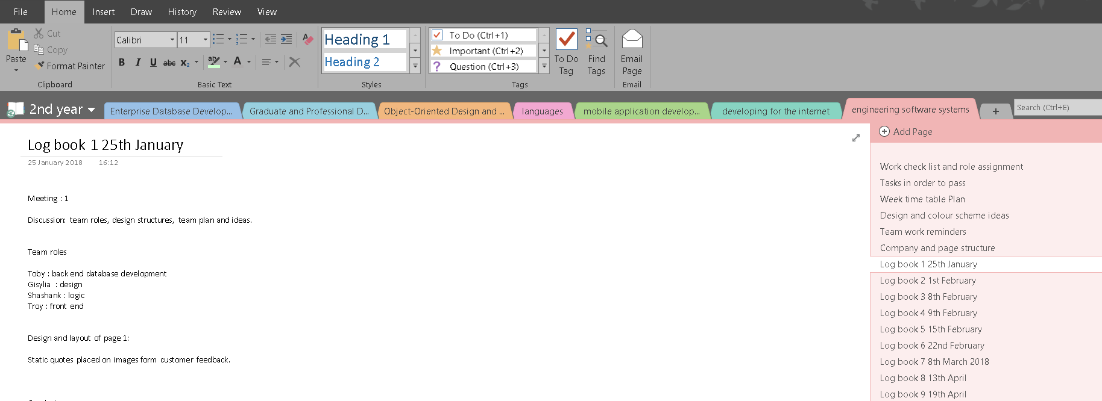

# Group task list

 Project Initiation and Planning - 20

**Belbin Self Perception Inventory (Gisylia)**

Evidence of team allocation using result (justify if not suitable).

To Do  Justification report of role allocation

To Do Individual test result

**Concept Map (toby- focus questions)**

Robust concept map with adequate focus questions

evidence of meeting expert concept map with good connectedness etc.

To Do Project Concept map

 Focus questions



**Risk Assessment and analysis table (troy)**

Evidence of sophistication in thoughts of risk evaluation.

Risk evaluation meets project

Evidence of applying a risk technique

To Do Risk Analysis table

To Do Justification of adopted risk analysis technique

**Project plan and representation**

Gantt chart reflects adequate dependencies, reasonable time allocation on tasks

PERT diagram reflects reasonable critical paths

Sophistication in thoughts of presented WBS

Evidence of busy lines and card on Trello board for project team and task management

To Do Gantt chart

To Do Work Breakdown Structure

To Do Trello board for project management

To Do PERT chart

  Analysis - 20

**System requirements (toby)**

Justification of development methodology

Evidence of the requirements meeting system/ user’s expectation

To Do System requirements (functional and non-functional)

To Do Report of justifying adopted development methodology

**System Models (toby)**

Presentation of use-case diagram and domain models

Evidence of translation of requirements into models

Justification for adoption of techniques for models such as story boards, class diagrams, sequence diagram, robustness diagram etc.

To Do System use-case,

To Do domain models,

To Do robustness diagrams,

To Do Sequence diagrams,

To Do  class diagrams

(12)

  Design - 20

**User Interface (Gisylia)**

 Good aesthetic and clean user interface

Easy to use/suitable controls (Button etc.)

Easy system navigation

To Do Interface design

**Architectural Design (Gisylia)**

Evidence in sophistication in thought of architectural design

* Architecture design

 Implementation - 30

**Version Control**

Good evidence of regular commit to GitHub

team managing system code through download and uploads from all participating team members

To Do System codes on GitHub

**Coding to standard**

Evidence of coding to standard, using proper indentations

appropriate use of classes and methods

good comments as appropriate

To Do System codes reflecting international coding standard

**Working Program**

Program works as describe

Meets user’s expectation and system requirements

To Do Working program/project

**Testing (Shashank)**

Written test plan

Evidence of performing acceptance test

Unit test code evidencing unit test

To Do Test plan and test result

To Do Unit test codes

Maintenance and support - 10

**User’s guide**

 Unambiguous user’s support guide for developed for the system

Easy to understand with no grammatical or spelling errors

To Do User’s guide

**Developer’s Guide**

A clear developer’s support guide developed for the system

Can easily help other developer to pick up development and maintain the system

No grammar and spelling errors

* Developer’s guide

 Total - 100

 Any innovation and additions

Any extra that add value to the system and process of development can get up to 10 points extra to reach maximum mark

10 (extra to reach maximum grade mark)

# Log books

### Log book 1 25th January

25 January 2018

16:12

Meeting: 1

Discussion: team roles, design structures, team plan and ideas.

Team roles

Toby: back end database development

Gisylia: design

Shashank: logic

Troy: front end

Design and layout of page 1:

Static quotes placed on images form customer feedback.

Conclusion

* No challenges were formed, we were all in agreement to the plan.
* List the different software and tools used
* Preliminary design layout

### Log book 2 1st February

01 February 2018

14:30

Discussions

5 mins (2:10pm)

* quick discussion on the different task each individual member of the team has done (everyone)
* Shared ideas and thoughts on the different aspect of the project (everyone)

Another 5 min discussion (3:36pm)

* creating a git hub account (completed by toby)
* Uploaded the different files and task that had been completed to git hub (Troy and toby)
* Uploaded task and information to google drive group (Gisylia, toby)

Tasks completed

 Troy -

* Created the three basic webpages layout
* Created the three folders for the different pages

 Shashank

* Reviewed php scripts
* Made a point to toby to plan it first the structure first as there is no physical visualization of the system

a written plan should be added and created for the ux page.

**Logic design (make it mobile friendly in jQuery) 6 weeks**

Toby -

* created all the php pages.
* Functions created
* Created git hub
* Created Gantt chart
* Created the database
* Created Microsoft project plan

Gisylia

* Created the design concepts and colour schemes
* Created a weekly plan on what need to be done during the week
* Written log books for the week
* Created team work reminder

 All tasks were complete for the week

 Actions/ tasks done during the session (4: 36pm)

 Toby and Shashank created the pert chart

 Troy and Gisylia created design for the login

Created a Trello list on the different design features we must do and create during the week

 Discussion on what we must do next week (4:20pm - 6pm)

* Discuss Team work reminders
* Concept map (troy, toby)
* Project proposal (Gisylia, Shashank)

Creating the design layout for the project login page

Representation of how the code should work, a discussion between toby and troy

* The logic of the buttons created by troy

 Troy

* Create a Site map for 6 pages, log in and admin will be the same page
* Dash page for the staff
* Dash board for the customers
* Control panel for the staff
* Clients dash board
* a trigger maps
* Trigger emails (the email will be triggered when the client clicks complete in the dash board) for the concept map
* Complete memories and revise the webpages
* **Log books**

Toby

* Upload code to git hub
* Create pert diagrams
* Concept map and domain model
* Class diagrams
* Class text
* Robustness diagram

Gisylia

* Create UI designs
* CSS pages
* Structuring the web pages

Shashank

* UI
* Login pages for the UI
* Mark buttons where they mean buttons
* Make sure the div have classes
* Filling the filed
* Creating the classes
* Button log in (give it a class)
* Adding necessary buttons if needed
* Removing buttons
* Implement validation for the code
* **Log books**

Admin dash board will be left to me

Discussion on the project proposal with Femi (17:12)

Technical feasibility talk

We decided not to use java instead web application using and array of techniques, create a web application where clients can sign up their properties

 Economic feasibility

 Organizational feasibility

### Log book 3 8th February

08 February 2018

14:05

14:05

Work we are going to do

 Toby

* use case text and use case diagrams
  + This was decided as he had created the database

 Shashank -

Gisylia

* completed the design layout and schemes report

14:57

 Meeting time

Pod room next week Friday

Extension the following Friday

 Tasks for the week

Troy

* find the assessment brief and have a look at what steps we need to take to gain an A in the project
* Break it down into the simple tasks

 Toby

* Finishing Gannt charts and use case texts
* implementation the code into the sign-up forms

Gisylia

* Ticket design for client and staff

 Shashank

* Look over git work when implementation is complete
* Work on front end of the dash boards
* Coding the dash boards

* Making a project plan
* Work break down structure

Overall general plan

 Re-create the Gantt chart

 Mapp the progress of the work

 Risk analysis - what the ricks are the description of the risks based on the work break structure

Add every task

Task we need to complete broken down

 Risks

* Things that could go wrong with the process

We decided to use the waterfall methodology as it followed the structure of the project development lifecycle that we like the most

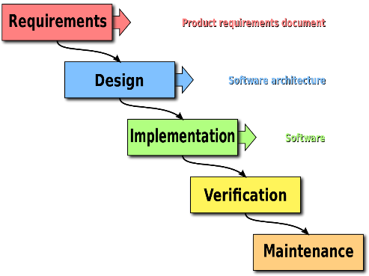

The only people who can compete are the staff and the cancel are the admin

 We had a discussion on the board on the structure of the system and different classes.

### Log book 4 9th February

09 February 2018

10:13

10:13 - pod room 3

 Agenda: discussing our deliverable and our work done

 What have we not done that we haven't done yet

* Creating a to do list on the different things we need to do and complete

* Creating a Gantt chart individual and general
* OOD design
  + use case text,
  + diagrams
  + Class diagrams
* Going through the use case diagrams

Adding another page (6 pages)

* Creating concept maps

Uploading the code to git

Discussing the concept maps

 What we must do

* Individual pert charts
* Concept maps

Front end discussion

Shashank start with the dash board

 Gisylia home page

Inspect element in google chrome

Pages completed in the artefact

Shashank Client dash board and staff dash board due Monday 12th February

* Someone must fall behind and create the different

Toby sent the SQL for the database to create it

 Gisylia conducted external research on how to create a successful log book and time stamp

 Creating a ticket page.

< div class = ticket >

  Adding maps to the address code

  Using URL

Concluded at 11 25

### Log book 5 15th February

15 February 2018

14:08

Start time 14:13 concluded: 5:03

Recap on work done

Work break down structure - Shashank

Risk analysis - troy

Group role report - Gisylia

Work we're doing today

* Create our individual concept maps
* Finish any outstanding individual assigned work

Questions for Femi

* Focus questions
  + How many do we need?
    - Up to us
    - Go by each para and think about the questions that arise
* Concept map for:
  + Individual
    - Personal evaluation
    - What are we (manager)
    - What you know
    - Belbin test

* group
  + All our individual analysis placed together
* Risk analysis table

* What do our individual Gannt charts have to be about?
  + So, it’s the tasks that Femi gave us in week 1 or 2
  + What do you need a Gantt chart for?

* Do we place all our group work on one doc?
  + Place In one doc - the group document
* Network activity
  + Pert diagram or Gantt chart

Femi next week class requirements 16:13

* Use case
* Domain model
* Robustness diagram
* Class diagram
* Design work
* Report layout lesson

Work during the week

Gisylia

* Finish CSS page
* Start / finish report

Troy

* Start / finish report

Shashank

* Start / finish report

Toby

* Start of finish report

### Log book 6 22nd February

22 February 2018

16:02

Start time 4pm

* Quick recap on tasks for the week

Toby will finish the staff page

Shashank

Gisylia continue CSS with modified code

Reconstruct the plan again then assign role to Shashank

### Log book 7 8th March 2018

08 March 2018

15:23

Start time - 3:05

 Had a discussion on the remining tasks we have left to do.

Added additional task to the check list

Updated the check list and allocated roles to each team member.

 Task for the week

Troy

- risk analysis

 Toby

* Focus questions
* Database development

Shashank

* Test topics and questions

Gisylia

* CSS pages
* Report structure
* Go over the code and note down all the classes in watch page.

 Talk with Femi

* This time next week - user interface design

 Toby - take out the alert in the customer dash board code

 End time - 16:45

### Log book 8 13th April

13 April 2018

15:07

Meeting - Recap session

We had a brief recap on where everyone's is now

* We only have two tasks left
  + Completing the group report
    - The lecture on how to do this is on the 19th
  + Completing the design of the website
    - The task is now between troy and Gisylia

Issues discussed

* Shashank found an issue with the current algorithm
  + Wrong date and time
  + Only assigns the jobs to James wood
    - He's the only worker as well as the admin
  + Femi hasn’t taught us the structure of the report and presentation

### Log book 9 19th April

19 April 2018

14:18

Writing a successful report

* Individual
  + Group log book must go in the group project folder
  + Individual log books can be an attachment to you report
* Boarder radius

### Log book 10 1st May

01 May 2018

13:01

Final logbook

* Presentation preparation

* Discussion on the order of the presentation
* Rehearsal on the talk we will give
* Discussion of the group report process